MISSION
To provide a respite weekend in the Colorado Rockies for married couples that have experienced the death of a child.  VISION  “Praise be to the God and Father of our Lord Jesus Christ, the Father of compassion and the God of all comfort, who comforts us in all our troubles, so that we can comfort those in any trouble with the comfort we ourselves receive from God.”  2 Corinthians 1:3-4  contact information  Kelly Packard  Executive Director  PHONE:  765-717-3892  WEBSITE:  www.livinghopemountainrespite.com  EMAIL:  info@livinghopemountainrespite.com  ADDRESS:  471 Ute Peak Drive  Livermore, Colorado 80536  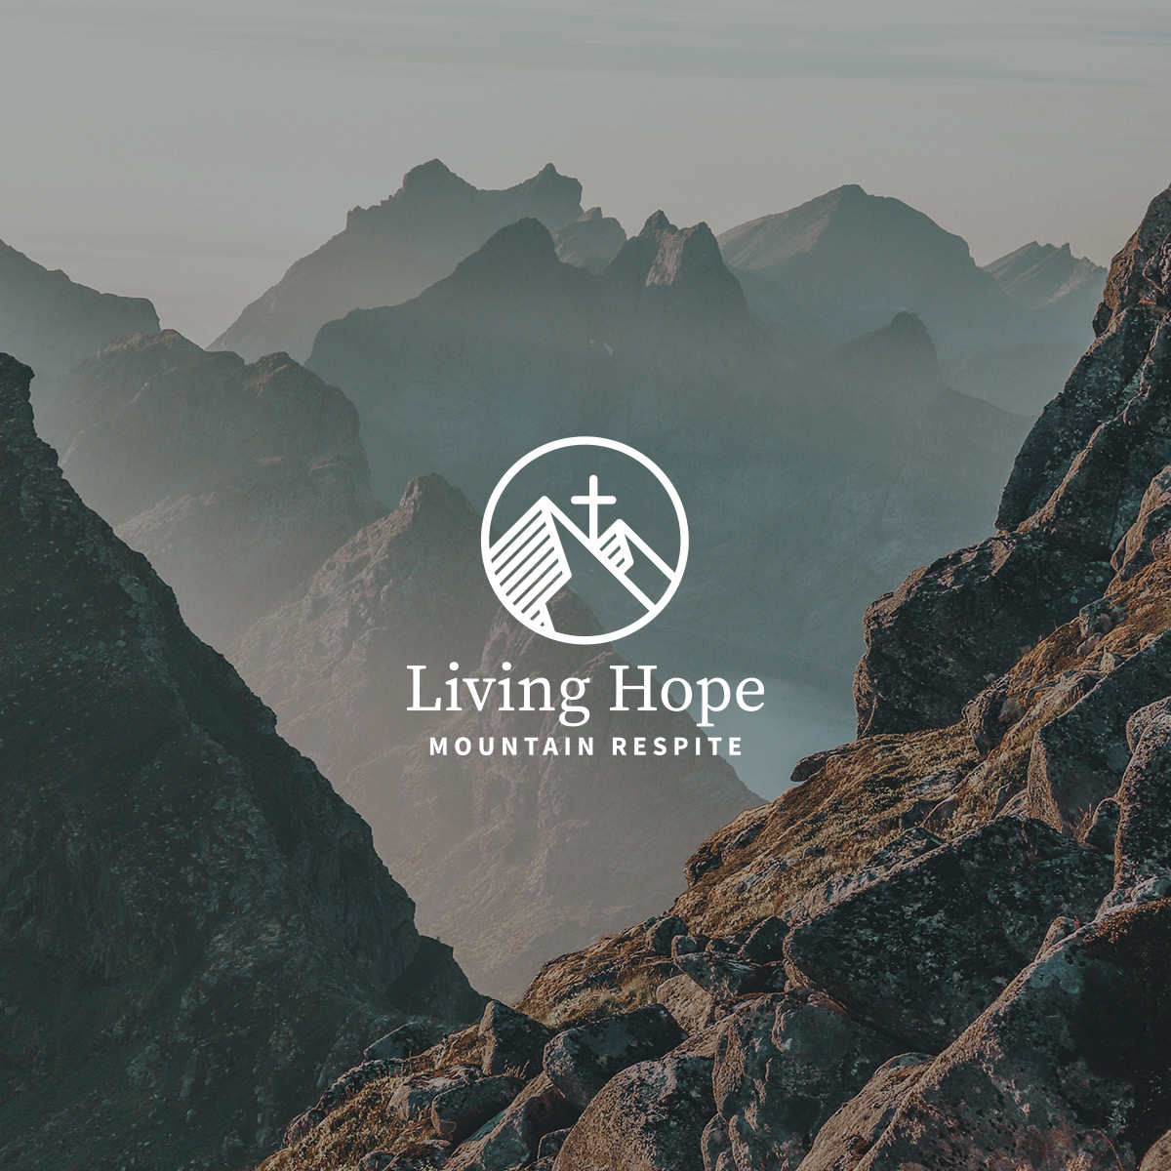 |  | gREETINGS/LAUNCH OF A NEW MINISTRY  Thanksgiving greetings to you and your family! We pray you are doing well in such strange and challenging times. Most likely, Thanksgiving and Christmas celebrations will look much different. Yet amidst these challenges, may we each anticipate unexpected joys, and even the development of unanticipated traditions for future holiday celebrations. Joy can still rise amidst difficulty and challenge.  Our personal journey of intense challenge, a grief inexplainable, has truly shown us that great difficulty can coexist with joy. This seemingly disjointed combination of grief and joy can lead to an unexpected and unanticipated future. That is our story.  Last May, Rich, Evan and I combined grief and joy when we officially launched Living Hope Mountain Respite. LHMR is a nonprofit ministry that provides a respite weekend in the Colorado Rocky Mountains for married couples that have experienced the death of a child.  The grief of Derek’s death remains interwoven into our lives.  The joy has unfolded in the foundation of this ministry, and its humbling positioning which allows us to step into others’ brokenness and comfort them with the comfort we ourselves have received from God (1 Corinthians 1:3-4).  ministry updatE  In September we hosted the first Living Hope Mountain Respite retreat weekend in Estes Park, Colorado. We remain humbled at the willingness of grieving marriages to expose their pain to us, and to allow us entry into such a sacred place. There was an immediate God-provided heart connection throughout the weekend, and the setting of the majestic Rocky Mountains communicated His limitless power over all things.  END-OF-YEAR GIVING  *Keep Living Hope Mountain Respite in mind as you consider making end-of-year financial gifts. LHMR is a tax-exempt nonprofit ministry under Internal Revenue Code Section 501 (c) (3). The website provides various giving options.  moving into 2021  We appreciate your remembrances in these areas as 2021 nears:  *Prayers for us individually, our marriage, and our courage to step directly into the pain of grieving marriages.  *Tell our story. Word of mouth has an important role in creating awareness about this specific marriage ministry.

