MISSION
To provide a respite weekend in the Colorado Rockies for married couples that have experienced the death of a child.  VISION  “Praise be to the God and Father of our Lord Jesus Christ, the Father of compassion and the God of all comfort, who comforts us in all our troubles, so that we can comfort those in any trouble with the comfort we ourselves receive from God.”  2 Corinthians 1:3-4  contact information  Kelly Packard  Executive Director  PHONE: 765-717-3892  WEBSITE:  www.livinghopemountainrespite.com  EMAIL:  info@livinghopemountainrespite.com  FACEBOOK:  @livinghopemountainrespite  ADDRESS:  471 Ute Peak Drive  Livermore, Colorado 80536  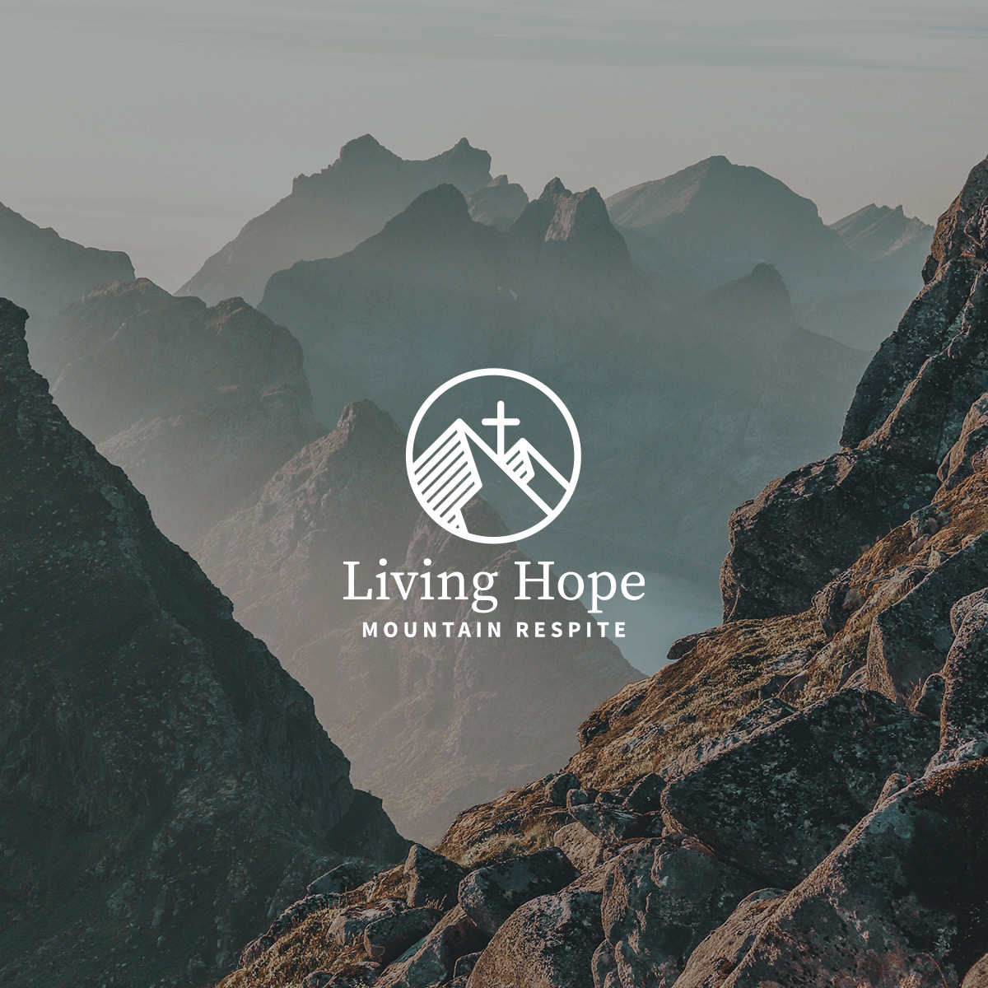 |  | spring 2022 ministry update  When we are asked to concisely summarize Living Hope Mountain Respite’s purpose in a casual (non-mission statement) way, we usually say “we point grieving marriages to Jesus.”  To be sure, our enemy cares when Jesus is acknowledged as the power and authority above all. We are also sure that obstacles and challenges are to be expected as we continue to elevate and acknowledge Jesus as our Living Hope.  These thoughts are affirmed in 1 Peter 5:8 “Be sober [well balanced and self-disciplined], be alert and cautious at all times. That enemy of yours, the devil, prowls around like a roaring lion [fiercely hungry], seeking someone to devour.”  We appreciate your specific prayer for our hearts and minds to be sober and alert, and that we do not fear the obstacles and challenges, but only fear our God. This fear is an awe-filled acknowledgement and personal intentional worship of the One who authors salvation through Christ Jesus.  As our Ministry Highlights below reveal, we have been blessed and strengthened as we continue stepping in obedience.  ministry Highlights  National Organizations: We have moved from networking with Fellowship of Christian Athletes (FCA) and The Navigators to actively partnering with these organizations. LHMR was included in the caregiving resource directory at a recent Navigators Care Giving Conference. We also anticipate setting a date for the first LHMR respite retreat hosted at The Navigators national headquarters in Colorado Springs.  Update on our partnership with FCA...  Upcoming event: FCA Coaches Time Out Marriage Reateat, Keystone, Colorado, July 29-31, 2022  We are excited to be the keynote speakers for the Fellowship of Christian Athletes (FCA) Coaches Time Out Marriage Retreat this July! 40 couples from across Colorado will be in attendance, and we covet your prayers as we prepare and throughout the entire event.  Continued Networking/Sharing LHMR: Most recently, we presented to the Fort Collins Church Network here in Northern Colorado. This is a large group of lead pastors from area churches. Much affirmation was spoken over us regarding the need for this specific grief-focused marriage ministry. Several pastors were able to voice their feeling of inadequacy as they step into the pain after the death of a child.  Google Ads Grant Update: The campaign has been very successful in creating exposure for LHMR. The LHMR website and Facebook page have seen significant growth in traffic. To date, the email inquiries expressing interest in attending a retreat do not reflect the growth of traffic on the site/Facebook page. As a result, the campaign is being monitored/adjusted to maximize the effectiveness of the grant, and to target new search words/phrases to broaden the exposure.  Family news  Our son, Evan, and his wife, Gabby, and their Alaskan Malamute, Mowgli, moved to Colorado from Indiana! We are delighted to have them within an hour’s drive and have already enjoyed our inaugural dog sitting adventure. (Yes, we’ve signed up for Round 2!)  Evan is an agent with New York Life, and Gabby was recently accepted into the Master of Social Work program at the University of Kentucky.  On May 12, 2022, we celebrated 32 years of marriage! The photo on the right was an unposed moment captured by one of Kelly’s former players. Very precious.  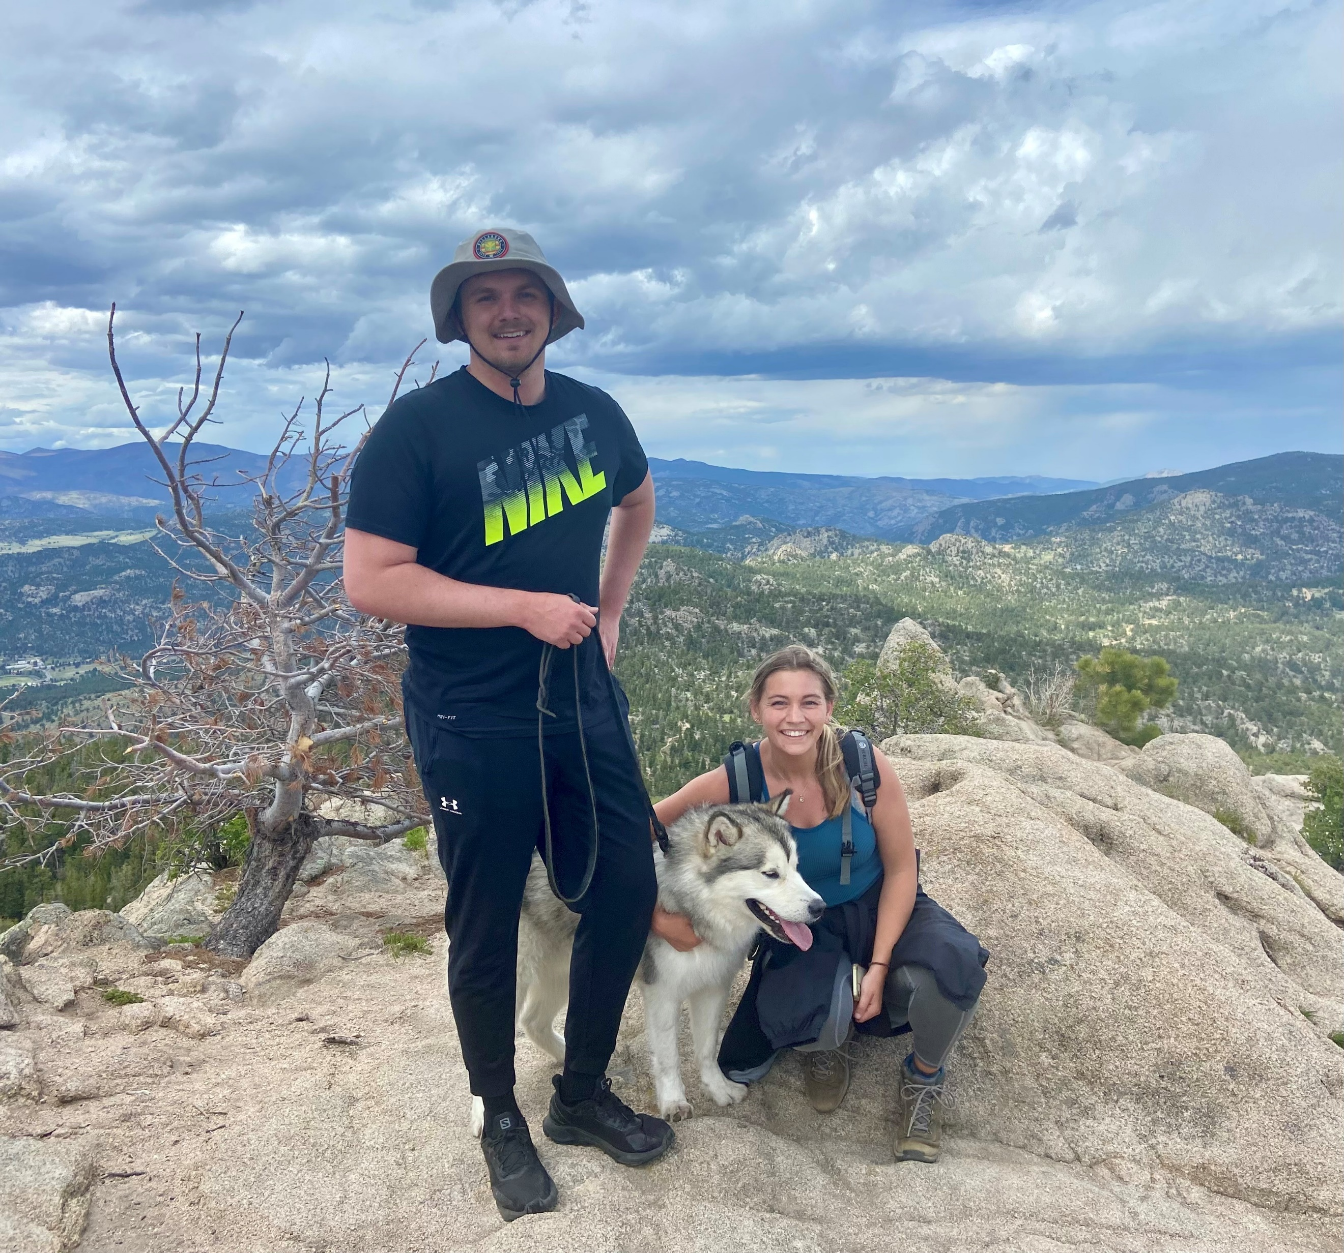 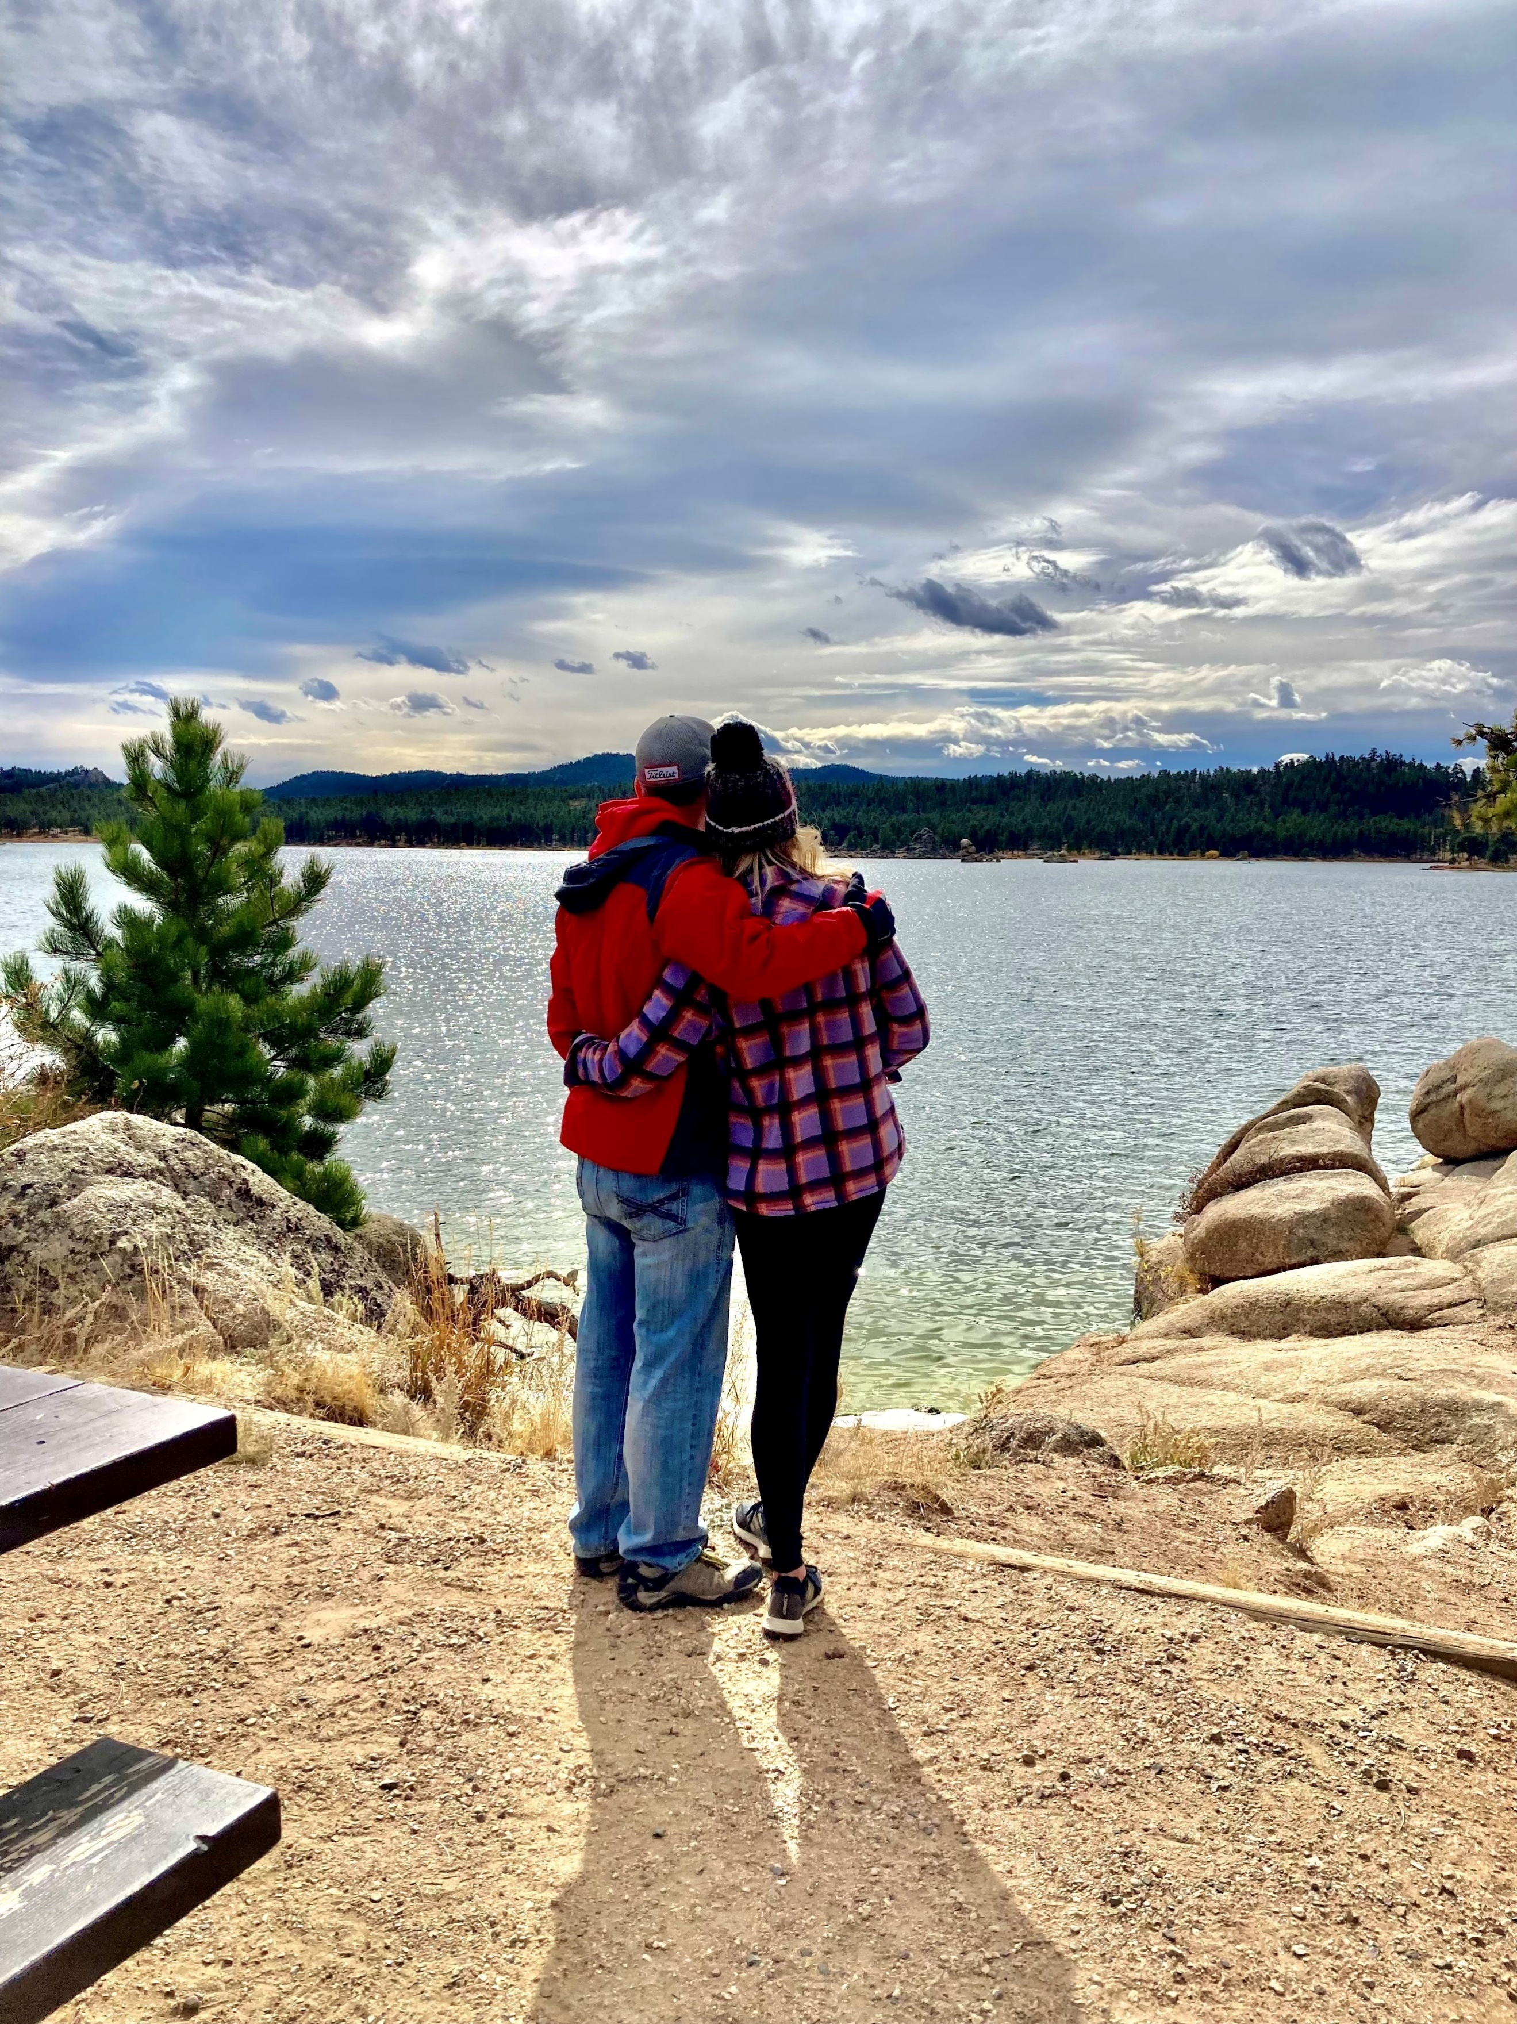, Evan, Gabby and Mowgli Rich and Kelly celebrate 32 years!  gratitude  We are grateful to share that LHMR continues to be blessed generously by donor gifts. Most of our donor gifts are one-time gifts. Our desire is to grow our recurring monthly gifts to allow the ministry to budget more effectively. We are also grateful for the faithful prayer support of the Living Hope Mountain Respite Prayer Team. If you desire to be added to the prayer team, just email our Prayer Team Coordinator, Tammy Resler at tammy.resler@sbcglobal.net.  prayer requests  We appreciate your specific prayers:  - That the Google Ads Grant continues to reach marriages experiencing deep grief from the loss of their child.  - Would you prayerfully consider opportunities in your area (organizations, marriage retreats, churches, Christian counseling centers, etc.) to share LHMR with to join our efforts to create awareness about our much-needed ministry?  - That God increases our patience and trust as we allow Him to reveal His desire for this ministry. Protection from discouragement.  - Prayers for us individually and our marriage. Specifically, that we remain “sober and alert” (1Peter 5:8).

